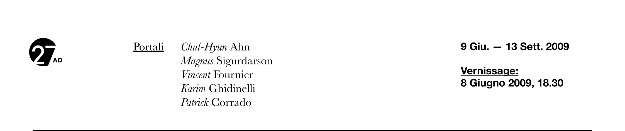
BIOGRAFIE DEGLI ARTISTI

Chul-Hyun Ahn, 1971
Korean artist Chul-Hyun Ahn was born in Busan, Korea. He lives and works in Baltimore, MD, USA where he achieved his MFA at the Maryland Institute College of Art. Before that he had Studied at Eastern Michigan University and Chu-Gye University of the Arts in Seoul, Korea.
He creates sculptures utilizing light, color, and illusion as physical representations of his investigation of infinite space. Ahn Is interest in the gap between the conscious and subconscious compels him to construct illusionistic environments providing a space for contemplation. Ahn is sculpture urges the viewer to consider man is boundless ability for physical and spiritual travel while exploiting illusions of infinity and the poetics of emptiness.
He has exhibited in several countries and is work is present in several reputed private and institutional collections in the USA.

Magnus Sigurdarson, 1966
Born in Reykjavik, Iceland in 1966, Magnus Sigurdarson studied art at Studio Cecil and Graves, Florence, Italy (1988), The Icelandic College of Arts and Crafts (1992) and Mason Gross School of the Arts, Rutgers University, New Brunswick, New Jersey, USA (1997). He currently lives and works in Miami Beach, Florida, USA.
A significant moment in Sigurdarson is career was a trip to China that he conducted with his family in 2005 around a residency program at The Chinese European Art Center in Xiamen.
He was literally confronted with every conceivable variation of The Other on an everyday basis; he
and his family as an Other to the locals and the foreign culture as an Other to him. He undertook a series of works that he is still carrying out in order to address this encounter. Transferring his discourse from the personal to the political, he poses questions about the progressing globalization, focusing on the homogenization of culture.
His work addresses the critical contradiction that the process of breaking barriers in order to understand and appreciate the unknown, will ultimately affect the elements that were foreign to each other beforehand, to the point of no return. The result is an inclination towards melancholy and nostalgia, abounding in Sigurdarson is latest works.

Vincent Fournier, 1970
Born in Ouagadougou, Burkinafaso in 1970, Vincent grew up in Britany, France. He lived in Paris and London and now is based in Brussels. He achieved a Degree in Visual Art in 1994 and the Diploma of Ecole Nationale de la Photographie in 1997.
Vincent works with photography and uses it to investigate, in an aesthetic way, some of the most atavistic aspects of human life: the relation between man and the universe. With his photography he gives us a sense of the finished and unfinished, he arouses in the observers a dual feeling of intensity and pleasurable aesthetic pleasure. He always tries to evoke a reconciliation between man and the universe.

Karim Ghidinelli, 1976
Karim Ghidinelli was born in Brescia, Italy, after having travelled and lived in many parts of the world, living with his family and studying, he now lives and works in Miami, USA.
His work is based upon passage, mark, and assurance. Identity is naturally a part of the evolutionary process of the passage; the mark is embodied by his distinctive trace on the page. As his work documents the passage of others, it simultaneously assures him of his own journey.
The mutation from print, to portrait, to metal, oil collage represents the myriad of influences he draws upon when composing his thoughts.
Being the living testament of an eclectic path, it is impossible for him to ignore the possibilities that surround him.
His eye reads them all as one.
The work needs to achieve a political identity and needs to express its provenance or dissidence, as life constantly reminds us of the inevitability of politics. The piece is never concluded; rather it
symbolizes the continuation of a phase, from himself to the public, from his interpretation to ours. Through its exposure the work obtains necessary nutrients, indispensable for further creation and
maintaining the link.

Patrick Corrado, 1971
The photographer and graphic designer Patrick Corrado was born in Bergamo in 1971. He achieved the Degree at the Fantoni Art School. The young artist cooperates with industry, fashion and design magazines.
Using images taken from the fashion world, his works, virtual decollages, made with the overlap of images, writings, marks and graphic elements, mortifies or exalts by means of bright red or dull black the modern symbolism made of aesthetic images. Using overlapping images, cuts and addictions of paint, writings and marks the artist determinates a “tidy caos”, symbol of the complexity of reality.

